Online Learning Impact analysis
A Project Work Report
Submitted in the partial fulfilment for the award of the degree of
BACHELOR OF ENGINEERING
IN
COMPUTER SCIENCE WITH SPECIALIZATION IN
BIG DATA ANALYTICS
Submitted by:
22BDA70035 RAJ SIGNH
22BDA70032 ANMOL RANA
22BDA70030 GAUTAM SINGLA
22BDA70006 SIDHARTH PUNDIR

Under the Supervision of:

DR. AMARDEEP SINGH

CHANDIGARH UNIVERSITY, GHARUAN, MOHALI - 140413,
PUNJAB
February, 2026

Table of Contents

Title Page
1. Project Planning & Task Definition
1.1 Background of the Study
1.2 Task Definition
2. Problem statement & objectives
2.1 Problem Statement
2.2 Objectives
3. Requirements Specification & System Architecture
3.1 Functional Requirements
3.2 Non-Functional Requirements
3.3 Block Diagram / System Architecture
4. Literature review / background study
4.1 Digital Attention Fragmentation
4.2 Replay Behavior in Online Learning
4.3 Learning Analytics & Early Warning Systems
4.4 Research Gap Identified
5. Methodology & technical approach
5.1 Research Methodology
5.2 Data Collection
5.3 Data Processing & Statistical Analysis
5.4 Normalization (Min-Max Scaling)
5.5 LFI Computation
5.6 RDP Computation
5.7 Risk Classification
5.8 Correlation Analysis
5.9 Visualization and Insights
6. Implementation progress / model development
6.1 Overview Dashboard
6.2 Risk Distribution Analysis
6.3 Correlation Analysis Results
6.4 Risk Detection Model
6.5 Demographic Insights
7: Results Achieved So Far
7.1 Development of Behavioral Indices (LFI & RDP)
7.2 Risk Classification Outcomes
7.3 Correlation Analysis Findings
7.4 Validation of Risk Detection Model
7.5 Dashboard Implementation Success
7.6 Overall Conclusion of Results
8. Documentation Quality, Prototype & System Resources
8.1 Project Prototype
8.2 Block Diagram
8.3 Experimental Setup
8.4 Equipment & Software Used

PROJECT PLANNING & TASK DEFINITION
  - Background
With the rapid adoption of online learning platforms, students increasingly face fragmented learning behavior and heavy reliance on replaying recorded content. However, institutions lack measurable behavioral indicators to identify students at academic risk.
This project aims to design a data-driven analytical system to measure:
- Learning Fragmentation Index (LFI)
- Replay Dependency Phenomenon (RDP)
- Their impact on Learning Effectiveness

1.2 Task Definition
Phase | Task
Phase 1 | Literature study + survey design
Phase 2 | Data collection + metric computation
Phase 2 | Dashboard development
Phase 2 | Risk detection model implementation
Phase 2 | Correlation analysis & validation
Phase 3 | Final research analysis and submittion
The project was divided into the following structured tasks:
Table 1: Phase and task relation

PROBLEM STATEMENT & OBJECTIVES
  - Problem Statement
Online learning environments often result in:
- Frequent task switching
- Short fragmented sessions
- Heavy replay dependency
- Reduced focus stability
There is no standardized behavioral metric to detect at-risk learners early.
This project proposes a dual-index behavioral model (LFI + RDP) integrated into an interactive analytics dashboard for early risk detection.

  - Objectives
- Develop measurable indices for fragmented learning behavior.
- Quantify replay dependency among students.
- Analyze correlation between behavioral indices and learning effectiveness.
- Develop a risk classification model.
- Design an interactive Power BI dashboard for institutional use.
- Provide early-warning analytics for academic intervention

REQUIREMENTS SPECIFICATION & SYSTEM ARCHITECTURE
  - Functional Requirements
- Collect student behavioral data
- Compute normalized indices
- Perform correlation analysis
- Classify risk categories
- Provide interactive filtering (Gender, Academic Year)
- Visualize distribution and trends

  - Non-Functional Requirements
- Scalable architecture
- Low-cost deployment
- Secure and anonymous data collection
- User-friendly dashboard interface
  - Block Diagram / System Architecture
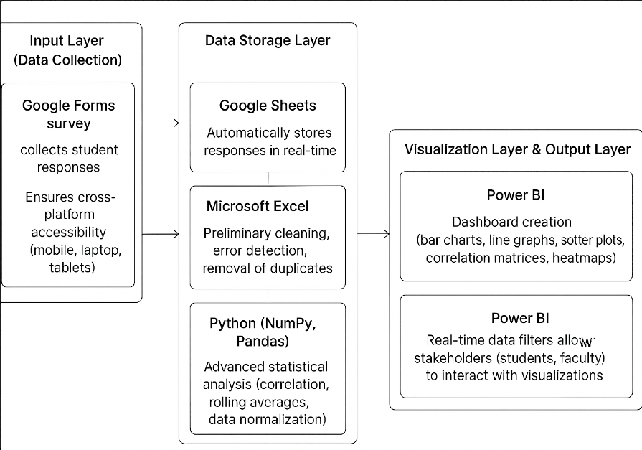
The system architecture integrates collection, storage, analysis, and visualization into a single pipeline.
Fig 1. System architecture
- Input Layer (Data Collection)
  - Google Forms survey → collects student responses.
  - Ensures cross-platform accessibility (mobile, laptop, tablets).
- Data Storage Layer
  - Google Sheets → Automatically stores responses in real-time.
  - Provides a structured tabular dataset for easy integration with Python.
- Processing Layer
Python:
- Cleaning
- Normalization
- Metric computation
- Correlation analysis
- Risk classification
- Visualization Layer & Output Layer
  - Power BI → Dashboard creation (bar charts, line graphs, scatter plots, correlation matrices, heatmaps).
  - Real-time data filters allow stakeholders (students, faculty) to interact with visualization
- Output Layer
Interactive dashboard for:
- Students
- Faculty
- Academic analysts
This architecture is modular, scalable, and cost-effective, making it suitable for deployment across multiple institutions.

LITERATURE REVIEW / BACKGROUND STUDY
The rapid expansion of online learning environments has transformed higher education. However, alongside flexibility and accessibility, concerns have emerged regarding attention fragmentation, cognitive overload, replay dependency, and reduced learning effectiveness. This chapter reviews existing research related to cognitive load theory, digital attention behavior, replay patterns in MOOCs, and early-warning systems in educational analytics, forming the theoretical foundation of the proposed dual-index model (LFI & RDP).
  - Digital Attention Fragmentation
Digital learning environments expose students to continuous notifications, multitasking opportunities, and hyperlinked content structures. These elements contribute to attention fragmentation, where learners frequently switch tasks or divide focus across multiple activities.
Attention Fragmentation in Digital Contexts
Several studies have shown that:
- Short learning sessions (<15 minutes) reduce deep processing.
- Frequent task switching decreases long-term retention.
- Multitasking during video lectures lowers comprehension accuracy.
Research on digital multitasking indicates that students who frequently switch between tabs, apps, or tasks demonstrate lower academic performance compared to focused learners.
Thus, attention fragmentation is not merely behavioral—it has measurable academic consequences.
This theoretical foundation supports the development of the Learning Fragmentation Index (LFI) as a quantitative metric.
  - Replay Behavior in Online Learning
Online learning platforms such as MOOCs allow learners to pause, rewind, and replay lecture content. While replay features enhance flexibility, excessive dependency may indicate cognitive difficulty or reduced real-time comprehension.
Replay Behavior in MOOCs
Research on Massive Open Online Courses (MOOCs) reveals:
- Students frequently pause or replay complex segments.
- Moderate replay improves understanding.
- Excessive replay correlates with confusion and low confidence.
Studies show that replay patterns can serve as behavioral signals:
- High replay frequency may indicate cognitive overload.
- Heavy reliance on replay reduces learning fluency.
- Replay time ratio is often higher among academically struggling students.
Cognitive Interpretation of Replay Dependency
Replay behavior may represent:
- Productive self-regulation (adaptive learning)
- Cognitive struggle (inefficient processing)
The challenge lies in distinguishing healthy revision from dependency. Therefore, the Replay Dependency Phenomenon (RDP) was conceptualized as a measurable behavioral index combining:
- Pause frequency
- Replay frequency
- Replay percentage
- Replay time ratio
- Self-reported reliance
This allows replay behavior to be operationalized analytically rather than interpreted qualitatively.
  - Learning Analytics & Early Warning Systems
Learning Analytics is an emerging field that uses data-driven methods to analyze student behavior and improve academic outcomes.
Early Warning Systems (EWS)
Early warning systems aim to:
- Identify at-risk students
- Predict dropout probability
- Provide timely interventions
Common predictive indicators include:
- Attendance
- LMS login frequency
- Assignment submission delays
- Assessment scores
However, most early warning systems focus on performance outcomes rather than behavioral cognitive patterns.
Behavioral Analytics Gap
Existing systems rarely measure:
- Fragmented attention patterns
- Replay dependency metrics
- Micro-behavioral digital learning habits
Most analytics rely on LMS logs instead of self-reported cognitive behavior.
This creates a need for a structured behavioral analytics model that integrates attention fragmentation and replay behavior into risk classification.
  - Research Gap Identified
From the review of existing literature, the following research gaps were identified:
- Fragmentation and replay behaviors are studied independently, but not integrated into a unified risk model.
- No standardized dual-metric index combines attention fragmentation and replay dependency.
- Most early-warning systems rely solely on performance data rather than behavioral cognitive indicators.
- Limited research exists on threshold-based classification using normalized behavioral metrics.
- Few studies provide interactive dashboards for institutional monitoring of digital learning behavior.

METHODOLOGY & TECHNICAL APPROACH
The success of this research project depends on a structured and systematic methodology that ensures reliable computation of behavioral metrics and meaningful interpretation of online learning patterns. This chapter presents the methodology adopted for designing, computing, and visualizing the Learning Fragmentation Index (LFI) and Replay Dependency Phenomenon (RDP).
The approach integrates survey-based behavioral data collection, normalization and statistical analysis using Python, and interactive dashboard visualization using Power BI. The goal is to convert theoretical behavioral constructs into measurable indicators and deploy them as a practical early-warning analytics system.
  - Research Methodology
The proposed research adopts a survey-driven, data visualization–based methodology to study Online learning among college students. The methodology is divided into four stages:
- Survey Design: The survey instrument was designed to capture:
A. Learning Fragmentation (LFI Components)
- Interruptions per session
- % Short sessions (<15 min)
- Task-switching frequency
- Session duration variability
- Daily session count
- Focus difficulty
B. Replay Dependency (RDP Components)
- Pause frequency
- Replay frequency
- % Content replayed
- Replay time ratio
- Replay reliance
C. Learning Outcomes
- Learning Effectiveness
- Course Satisfaction
- Self-Reported Performance
- Demographic variables included:
- Gender
- Academic Year
- Data Collection:
  - Responses were collected anonymously to reduce stigma and encourage honest self-reporting.
  - 80 students participated.
  - Responses were collected electronically.
  - Data stored in CSV format.
  - Each student assigned unique Student_ID.
  - Ethical participation ensured voluntary submission.
- Data Processing & Statistical Analysis
Processing was performed using:
- Python (NumPy, Pandas)
- Microsoft Excel (basic validation)
Cleaning & Validation
- Checked missing values
- Verified numeric data types
- Removed inconsistencies
Normalization (Min-Max Scaling)
Each behavioral variable was normalized to 0–1:

$$Normalized=\frac{\left(X − Min\right)}{\left(Max − Min\right)}$$
LFI Computation
$$LFI=\frac{N_{1}+N_{2}+N_{3}+N_{4}+N_{5}+N_{6}}{6}$$
RDP Computation
$$RDP=\frac{P_{1}+P_{2}+P_{3}+P_{4}+P_{5}}{5}$$
Risk Classification
Table 2: Risk Classification
Condition | Category
LFI < 0.65 AND RDP < 0.60 | Low Risk
One above threshold | Moderate Risk
Both above threshold | High Risk

Corelation Analysis
Pearson Correlation used to examine:
- LFI ↔ Learning Effectiveness
- RDP ↔ Learning Effectiveness
- LFI ↔ RDP
- Visualization and Insights:
Power BI dashboard included:
- KPI Cards (Avg LFI, Avg RDP, High Risk %)
- LFI & RDP Distribution (Histogram)
- Scatter plots with trend lines
- Risk zone classification scatter
- Demographic comparisons
The dashboard provides interactive filtering for gender and academic year.

- IMPLEMENTATION PROGRESS / MODEL DEVELOPMENT

  - Overview Dashboard
- Average LFI: 0.51
- Average RDP: 0.47
- Average Learning Effectiveness: 6.29
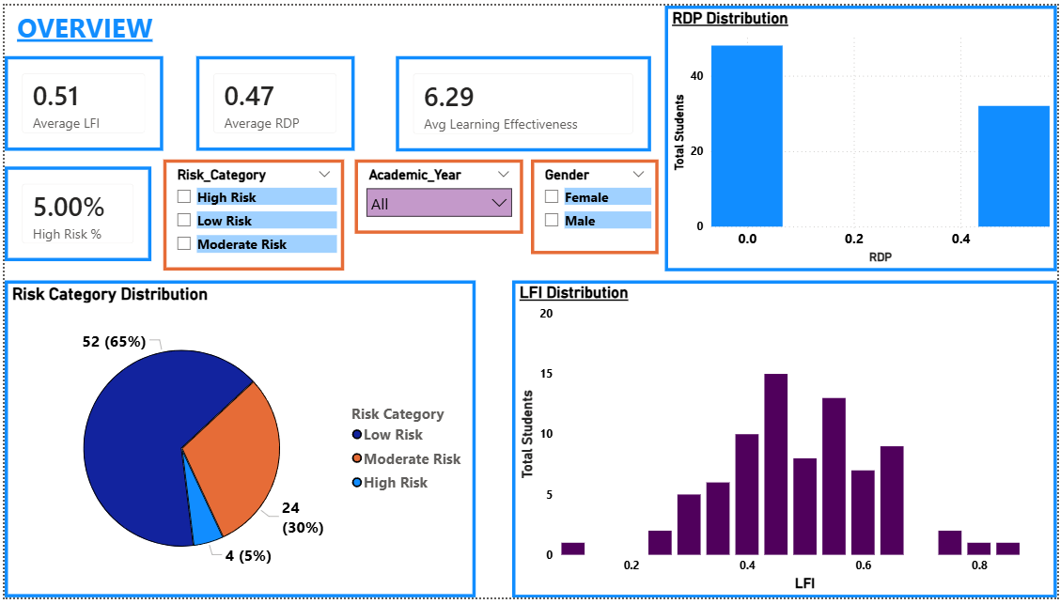
- High Risk Percentage: 5%
Fig 2. Overview dashboard

  - Risk Distribution
- 65% Low Risk
- 30% Moderate Risk
- 5% High Risk
  - Correlation Analysis
- Slight negative correlation between LFI and Learning Effectiveness
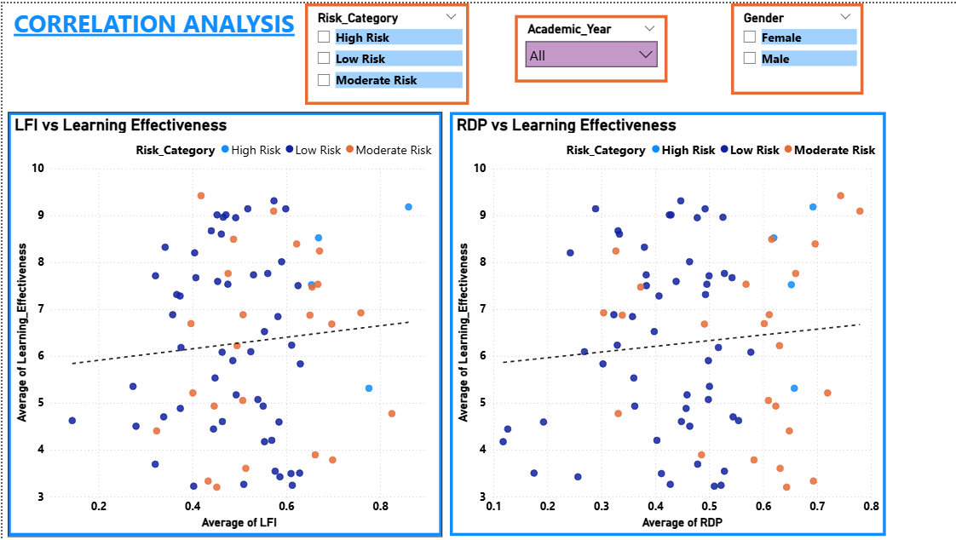
- Moderate positive relationship between LFI and RDP
Fig 3. Correlation analysis

  - Risk Detection Scatter Model
Quadrant division:
- Top-right: High risk
- Bottom-left: Low risk
- Mixed zones: Moderate risk

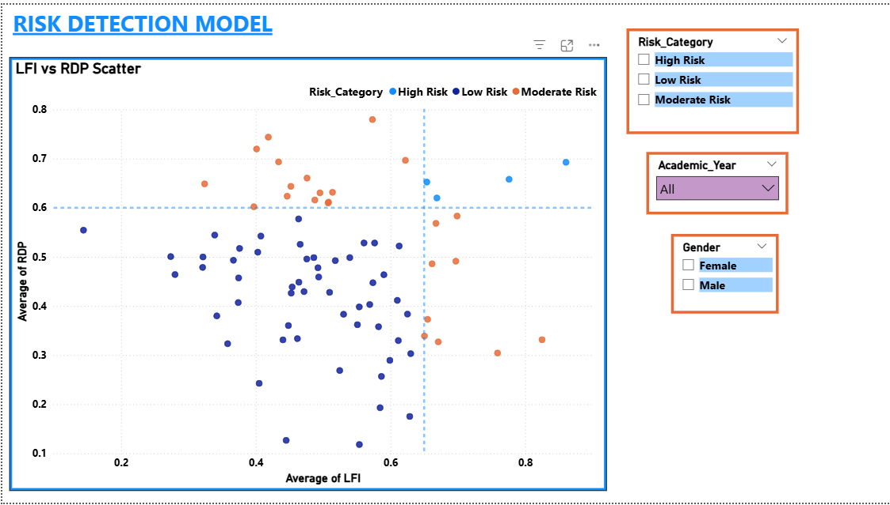
Fig 4. Risk Detection model

  - Demographic Insights
- Risk Category by Academic Year
- Average LFI by Gender
- Average RDP by Academic Year
This shows:
- Behavioral variation across years
- Gender-based comparison
- Academic progression patterns

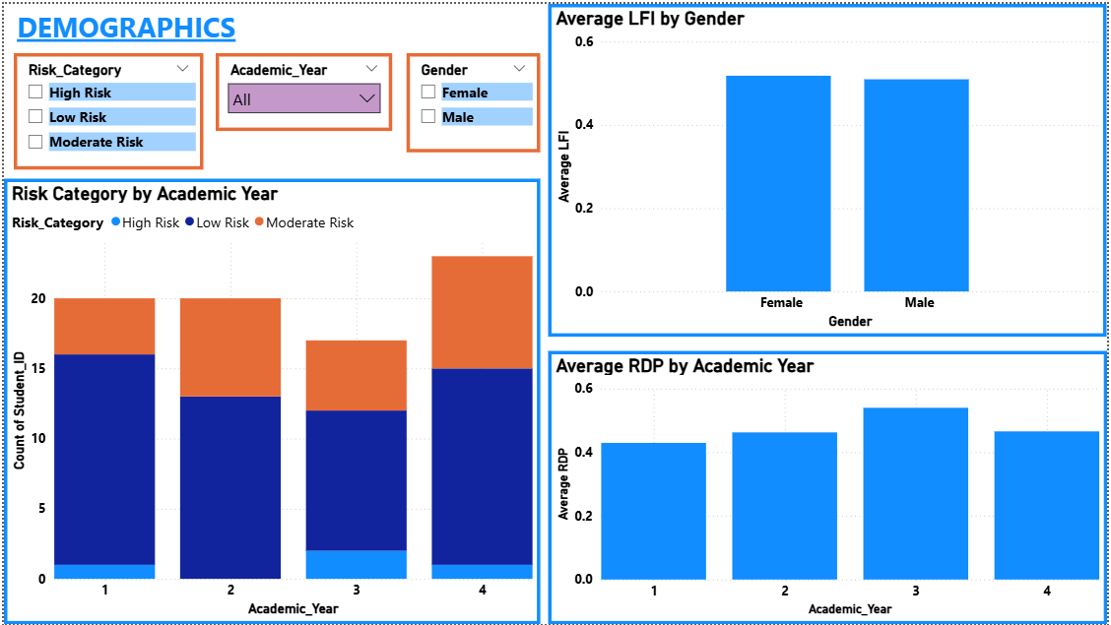
Fig 5. Demographics analysis

- RESULTS ACHIEVED
This section presents the major outcomes obtained from the implementation of the Online Learning Impact Analysis system, including behavioral metric computation, correlation analysis, and risk classification model deployment.

  - Development of Behavioral Indices (LFI & RDP)
The project successfully operationalized two abstract behavioral constructs into measurable quantitative indices:
- Learning Fragmentation Index (LFI)
- Replay Dependency Phenomenon (RDP)
Both indices were computed using normalized behavioral variables (Min–Max Scaling), ensuring consistency and comparability across students.
The computed overall averages were:
- Average LFI: 0.51
- Average RDP: 0.47
- Average Learning Effectiveness: 6.29
These values indicate moderate levels of fragmentation and replay behavior within the sampled population.

  - Risk Classification Outcomes
Using the dual-threshold risk model:
- LFI threshold = 0.65
- RDP threshold = 0.60
Students were classified into three categories:
Table 3: student categories
Risk Category | Percentage | Interpretation
Low Risk | 65% | Stable learning behavior
Moderate Risk | 30% | One behavioral indicator above threshold
High Risk | 5% | Both indicators above threshold

The results demonstrate that while the majority of students fall into the Low Risk category, a measurable proportion (5%) exhibits significant behavioral vulnerability, justifying the need for early detection systems.

  - Correlation Analysis Findings
Pearson correlation analysis was conducted to examine relationships among behavioral indices and learning effectiveness.
Observations:
- LFI vs Learning Effectiveness
  - Slight negative correlation observed.
  - Higher fragmentation tends to reduce learning effectiveness.
- RDP vs Learning Effectiveness
  - Moderate negative pattern visible.
  - Excessive replay reliance may reflect comprehension difficulty.
- LFI vs RDP
  - Moderate positive association.
  - Students with fragmented attention often demonstrate higher replay dependency.
These findings align with cognitive load theory and multitasking research discussed in the literature review.
  - Validation of Risk Detection Model
The quadrant-based scatter visualization (LFI vs RDP) clearly separates students into distinct behavioral zones:
- Bottom-left quadrant → Low Risk
- Top-right quadrant → High Risk
- Mixed quadrants → Moderate Risk
The threshold-based model successfully:
Segmented students into meaningful risk groups
Demonstrated visual interpretability
Supported early-warning identification
This confirms that the proposed model is practically implementable and analytically valid.
  - Dashboard Implementation Success
The Power BI dashboard achieved the following:
- Real-time filtering (Gender, Academic Year)
- Interactive KPI summary
- Clear behavioral distribution visualization
- Demographic comparison analysis
- Risk segmentation model visualization
The system is functional, scalable, and suitable for institutional monitoring.

Overall Conclusion of Results
The pilot study confirms that:
- Behavioral fragmentation negatively impacts learning effectiveness.
- Replay dependency correlates with cognitive difficulty.
- A dual-index model provides more reliable risk classification than single-variable analysis.
- The dashboard framework can serve as an institutional early-warning system.

- DOCUMENTATION QUALITY, PROTOTYPE & EXPERIMENTAL SETUP
  - Project Prototype
A functional Power BI dashboard was developed consisting of four modules:
- Overview Dashboard
- Correlation Analysis
- Demographic Analysis
- Risk Detection Model
The prototype successfully demonstrates:
- Computation of LFI and RDP
- Threshold-based risk classification
- Correlation analysis
- Interactive filtering by Gender and Academic Year
Screenshots of the dashboards are included in this report as implementation proof.

  - Block Diagram & System Architecture
The system follows a structured five-layer pipeline:
- Data Collection – Google Forms
- Data Storage – Google Sheets
- Data Processing – Python (Normalization & Computation)
- Risk Classification – Dual-threshold model
- Visualization – Power BI Dashboard
This modular architecture ensures scalability and ease of deployment.

  - Experimental Setup
- Participants: 80 students
- Data Collection: Online survey
- Processing: Python (Pandas, NumPy)
- Visualization: Power BI Desktop
The system was evaluated based on clarity of risk classification, correlation validation, and usability.

  - Equipment & Software Used
Hardware:
- Standard laptop/desktop
- Internet connectivity
Software:
- Google Forms
- Google Sheets
- Python (NumPy, Pandas)
- Microsoft Excel
- Power BI Desktop

